DELETING RESOURCES

- First need to add HTTPDELETE in our RestaurantsControllers.cs
- Create file in Application module under Restaurants/Commands/DeleteRestaurant/DeleteRestaurantCommand.cs
  - Make sure public class
  - Past id information to our primary constructor
  - Create a field that is going to store such information about id of a given restaurant.
  - Create IRequest without any additional generic parameter because we don’t need to return any value from a given command or query handler
  - Example IRequest<IEnumerable<RestaurantDto?>>
    - IRequest is interface
    - <IEnumerable<RestaurantDto?>> is generic parameter if we want to return it to client
- Now create DeleteRestaurantCommandHandler.cs in similar folder
  - Make sure a public class
  - Implement request handler called IRequestHandler
  - Pass DeleteRestaurantCommand as a generic parameter
  - Generate missing code > missing member

STEP BY STEP TUTORIAL
- First need to add HTTPDELETE in our RestaurantsControllers.cs
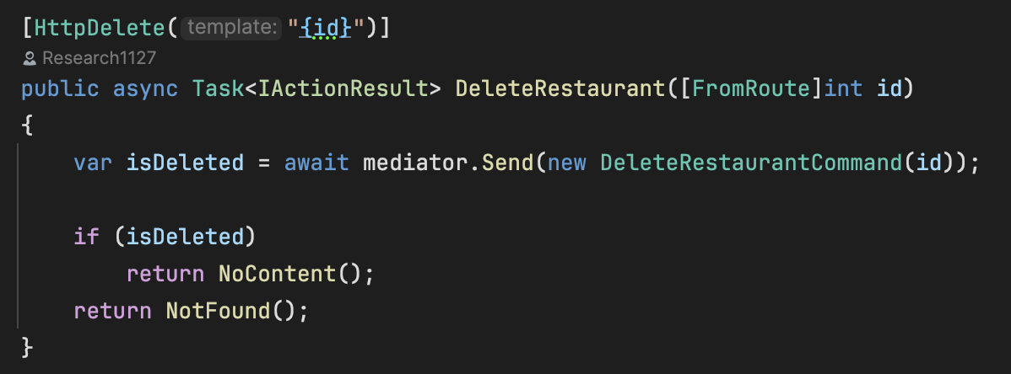
- Create file in Application module under Restaurants/Commands/DeleteRestaurant/DeleteRestaurantCommand.cs
  - Make sure public class
  - Past id information to our primary constructor
  - Create a field that is going to store such information about id of a given restaurant.
  - Create IRequest without any additional generic parameter because we don’t need to return any value from a given command or query handler
  - Example IRequest<IEnumerable<RestaurantDto?>>
    - IRequest is interface
    - <IEnumerable<RestaurantDto?>> is generic parameter if we want to return it to client
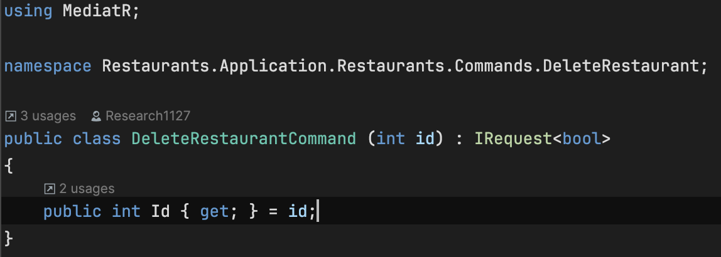
- Now create DeleteRestaurantCommandHandler.cs in similar folder
  - Make sure a public class
  - Implement request handler called IRequestHandler
  - Pass DeleteRestaurantCommand as a generic parameter
  - Generate missing code > missing member
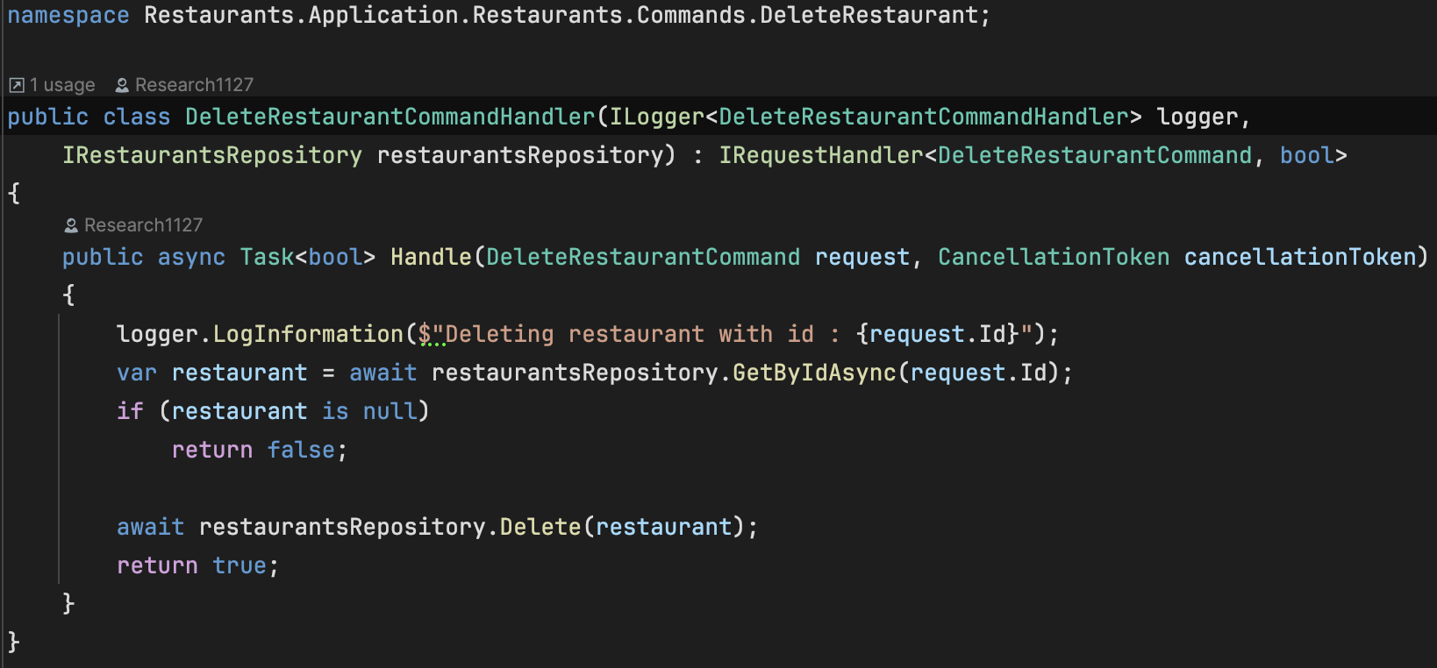
- Create task in the IRestaurantRepository
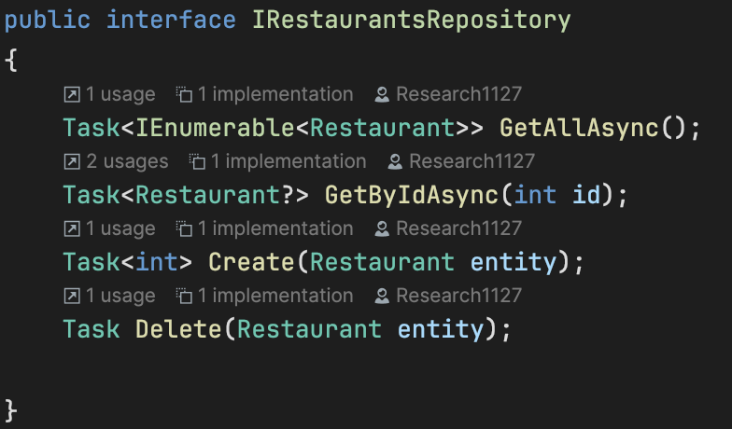

- Implement the method in RestaurantRepository
